Decision Tree

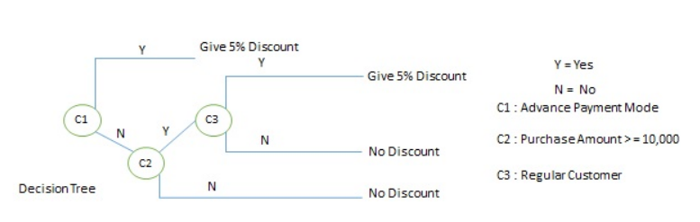

Decision Table

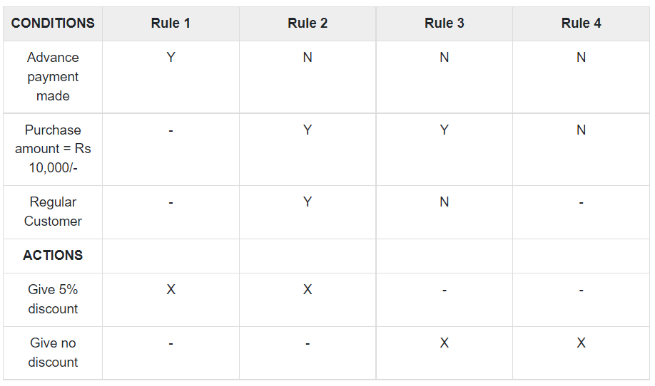

Structured English

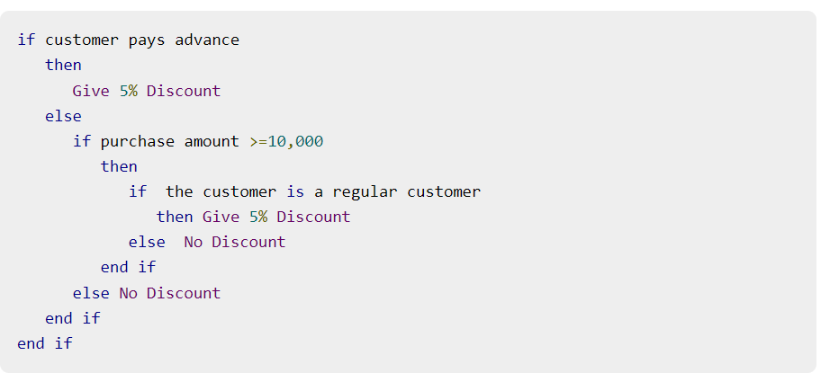

Reference

1. <https://www.tutorialspoint.com/system_analysis_and_design/system_analysis_and_design_structured.htm#>